**DVRPTR_V1 Hardware Quick start Guide**

**Version 1.00 May 2013**

**Author: Bruce Given**

**Website: www.dvrptr.net**

**Email: Bruce.Given@gmail.com**

Thank you for purchasing the DVRPTR_V1

The purpose of this sheet is to assist you in getting your DVRPTR_V1 Hardware up and running as quickly as possible.

**PLEASE NOTE THE FOLLOWING**

1. The DVRPTR_V1 is shipped in two options these are complete unit packaged in an aluminum metal case or as a populated fully tested PCB ready for mounting, in both cases cables are optional extras.

1. The unit/board as shipped**\*** requires an external D/C power adapter to function.

If you plug the unit in and the red led just flashes continually please check your DC adapter.

1. The screws used on the Case are Torx T10 using any other tool will probably strip them and make the case more difficult to open.
2. An excellent web site to get you started for windows and Linux is

<http://www.dstar101.com/DVRPTR.htm>

* The DVRPTR_V1 can be configured to be powered from the USB, this requires a hardware modification to the board. Instructions can be down loaded from the Yahoo Group here:

<http://groups.yahoo.com/group/DVRPTR_V1/files/Schematics%20%26%20Diagrams/>

I f you indeed to run a AMBE or other add-on modules from the DVRPTR_V1 then please don’t do this mod

**DVRPTR_V1 Hardware Quick start Guide**

**Version 1.00 May 2013**

Looking at the end of your DVRPTR_V1 here is what you will see.

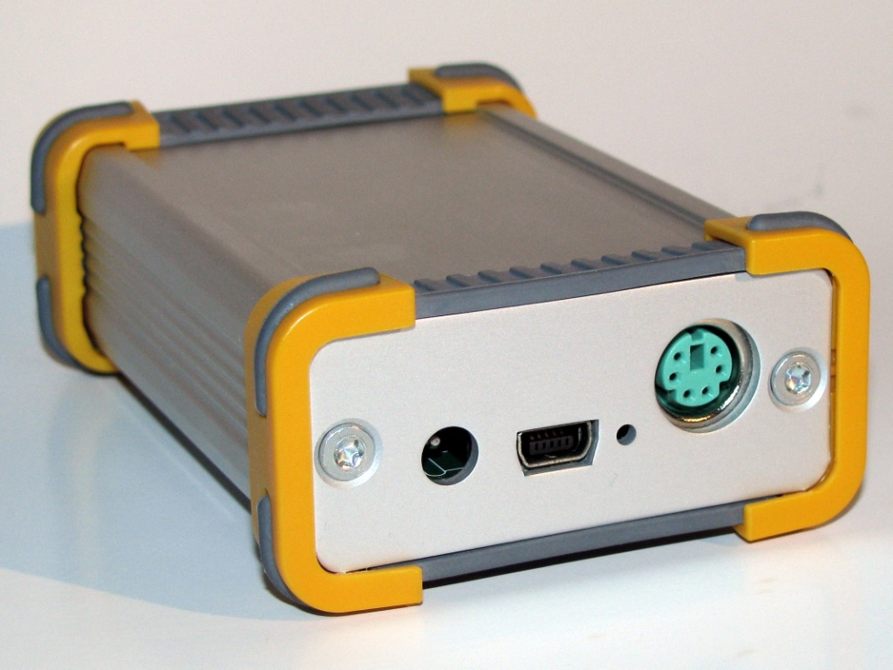

**Connectors and indicators used on the board from the left**

1. DC Connector

Standard 5.5m outside diameter, Inside Diameter is 1.9mm

Center connector is + Input voltage from 7.5 to 13.8Volts

1. USB Mini B Connector for computer interface, standard USB2.0 interface
2. LED indicating board status
3. MiniDin 6 Pin Radio Interface (Pin out detailed in the following pages )

**LED Status**

1. 1-2 Quick red flashes as DC plugged in is normal
2. Normal operating Mode with Radio, USB and DC Power plugged in  
   Red and green LED’S will flash for a second or so then the go out.
3. Radio transmit Red LED lights
4. Radio receive Green LED lights
5. Continuous Flashing Red LED = USB plugged in but no external power supply plugged in

**DVRPTR_V1 Hardware Quick start Guide**

**Version 1.00 May 2013**

**Radio Connector pin out**

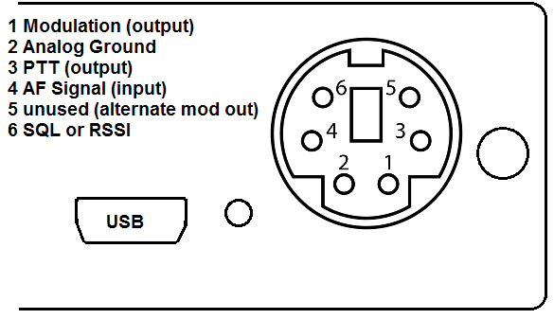

We are slowly building a collection of radio wiring diagrams as users contribute information on their setups to the Yahoo group.

Check out <http://groups.yahoo.com/group/DVRPTR_V1/files/> and if it’s not there and you seem to be having a problem please don’t hesitate to ask on the mailing list in the Yahoo group